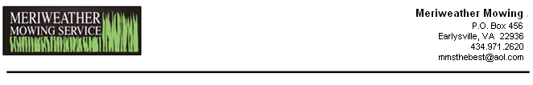

Dear [CustomerFirstName]:

Hi there! We’ve done some mowing for you in the past, and were wondering if you might need some help along those lines this year. After all, everybody just loves a comeback, don’t they? Picture us driving our zero-turn across your yard in super slow-mo…theme to “Chariots of Fire” playing…neighbors cheering…confetti dropping….tears flowing. That would we awesome.
To make this heartfelt scenario a reality, contact us at 971-2620 or MMSthebest@aol.com. By the way, our low, low price for your property is [MowCost].

Thank you
Rod & Dave

